What are you eating? A dietary assessment assignment

**LifeSci 2N03 assignment #2 (25% of final grade)**

**Due: Nov 8th 11:59 on Avenue**

**Background:** Food literacy is a relatively new concept in Canada. It is defined as:

The ability of an individual to *understand* food in a way that they develop a *positive relationship with it*, including food skills and practices across the lifespan in order to navigate, engage, and participate within a complex food system. It’s the ability to make decisions to support the achievement of *personal health* and a sustainable food system considering environmental, social, economic, cultural, and political components. (Cullen, 2015, p143.)

In order for us to *understand* food and enhance our own food literacy, we must be more aware about what we are eating and how our diet compares to recommendations. There are various international recommendations, but in Canada, the most common reference standards are the new Food Guide and the Institute of Medicine’s Dietary Reference Intakes (DRIs). Canada’s Food Guide (CFG) provides broad recommendations on the types of foods we should try to eat and eating habits that foster healthier choices. The DRIs provide specific reference values for energy nutrients, water, vitamins and minerals. Comparing your diet to DRI values provides a ‘close-up’ analysis of your diet. In this assignment, you will compare your diet to DRI values and to the CFG.

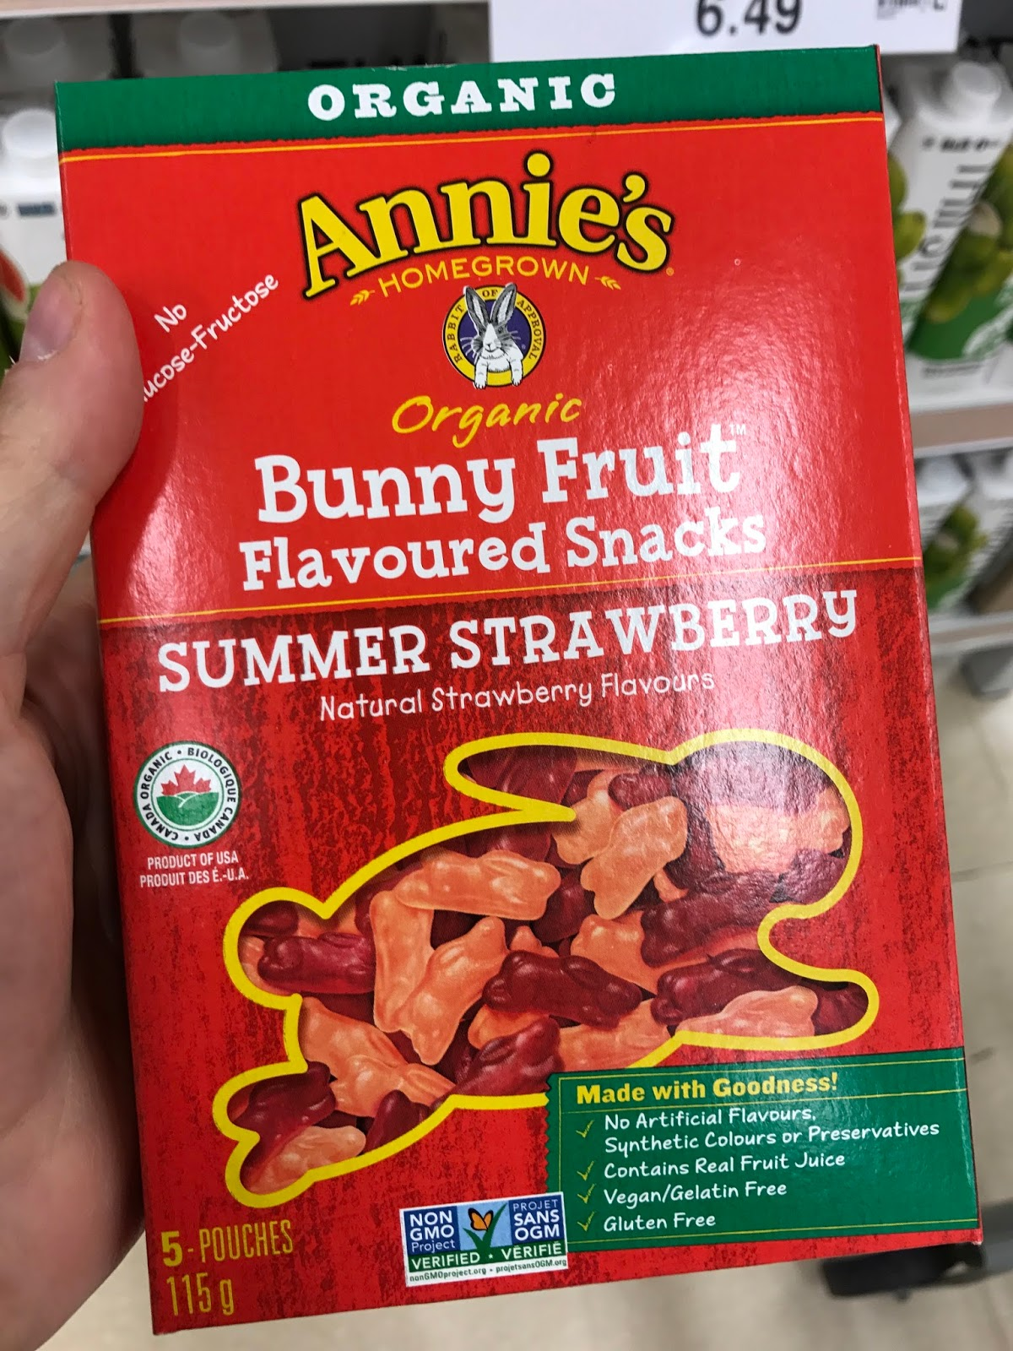

Another aspect of food literacy is being a smart consumer and understanding food packaging so that you can make good decisions in the grocery store*.* But*,* how can consumers be expected to understand foodwhen claims on packages are so confusing, and mixed messages are being sent about products? Take Annie’s Organic Bunny Fruit Snacks, for example (image on the right). There is some pretty convincing advertisement on the package for these snacks, like *organic, natural, gluten free*, but the snacks are 48% sugar. Probably not the best snack for children (or undergrads)!

**Objectives:** To complete a 5 day diet record, analyze your diet using the Diet and Wellness Plus software, compare your diet to DRI values and CFG, and suggest dietary modifications to better align your diet with recommendations. You will also locate 3 examples of products (foods or beverages) that have potentially misleading advertisements on the packaging and may conceal unhealthy ingredients.

**How to complete the assignment:**

**Please note:** If you have questions or issues with using Diet and Wellness Plus, please direct your questions over email to your TA Danial Aminaei ([aminaeid@mcmaster.ca](mailto:aminaeid@mcmaster.ca)). You may ask general questions about this assignment during course office hours, but Danial will assist with any software-related questions.

**Part A: Track your diet and enter the data**

1. Obtain the Diet and Wellness Plus software. This can be purchased through the Bookstore or directly on the Nelson website (<https://bit.ly/2UFgROX> Discount code: **DIGITALB2S1479**)
2. Create a profile for the Diet and Wellness Plus software. Use instructions in the PowerPoint posted on Avenue.
3. Using the template provided, record what you eat and drink for 5 days, including 3 weekdays and 2 weekend days within a 7-day period. It is important that the days that you track your food intake for are reflective of your typical diet. So, if you are sick and are eating only chicken noodle soup for 5 days, consider waiting until your diet returns to ‘normal’ so that your analysis reflects your typical diet.
4. Enter the foods and beverages into the Diet and Wellness Plus software.

**Tips for entering food into the software:**

* + The food items from some major restaurants (i.e., Milestones) are in the database. You can search your entire meal without entering the individual components of the meal, as shown below with the sandwich.
  + Don't forget to track water intake and other beverages.
  + While the software has over 55,000 foods, it is not perfect and may not have all of the foods you consumed. Select a food item from the database that is most like the food you consumed. Make your selection based on how the food is prepared (boil versus BBQ) or whether there is salt added, for example. Make note of the foods that you do this for, as this may influence your interpretation.
  + If you tend to eat the same foods each day (i.e., oatmeal every morning), you can “favourite” the food item so that it is easier and faster to search for each time you enter your food.
  + You can create a custom food if the food you are searching is not in the database. Use the food label on the package for nutrient information.
  + If you ate a ham sandwich or another meal containing multiple ingredients (i.e., a pasta dish, stir fry etc.), you must enter each component of the meal separately, as shown below.

Example: Ham sandwich

Food Amount

Whole wheat bread 2 slices

Lean smoked ham 2 oz

Non-hydrogenated margarine (regular) 1 tsp

Lettuce 0.25 cup

Mustard 0.5 tsp

Mayonnaise 1 tbsp

* + If you made a meal for multiple people or multiple days (i.e., ate a stir fry for one meal and had leftovers for another meal the next day), ensure that you divide the ingredients by the number of servings consumed. For example, if in a stir fry you added 2 breasts of chicken but this stir fry was consumed over 2 days, enter 1 breast (~3oz) for each day.

**Part B: Generate reports for your diet**

1. Generate a report of your diet for each day by clicking “Reports”.
2. Under “Diet & Activity Reports” click on “Daily Food Log”.
3. Do this for each day that you tracked. Include the summaries for all 5 days in your final submission.
4. Under “Diet & Activity Reports” click on “Intake vs. Goals”. Select the date range that covers the 5 days that you recorded your diet. This report will show you your average intake of nutrients over the 5 days. The days that you recorded your diet should be highlighted in green on the drop-down calendar. Save the PDF. Do not include this report in your final submission, but you will be abstracting data from this report. You can check out the sample report that I posted on Avenue.

*\*\*Please note: Alpha-tocopherol is vitamin E. Use the vitamin A recommendations in IU and compare to your intake in IU, not RAE.*

**Part C: Compare your diet to DRI values**

1. Use the data abstraction table template on Avenue.
2. Compare your intakes with the DRI values for macronutrients, micronutrients and your Estimated Energy Requirement (EER).
   * To compute your EER, use the equation from page 82 in the DRI Essential Guide posted on Avenue.
   * To compute your Adequate Macronutrient Distribution Ranges (AMDRs) for carbohydrate, fat and protein, multiply your EER x the coefficients for each energy-yielding nutrient (from course notes, DRI Essential guide, or custom course textbook)
3. Write in your nutrient recommendations for the nutrients listed in the table. Recommendations vary based on sex, age, pregnancy and lactation status. Record the AMDR for the macronutrients. For all other nutrients, record the RDA. If the RDA is not given, record the AI. Some of the recommendations in the Diet and Wellness report are not specific to your age or sex. Use the DRI Essential Guide to fill out your recommended values. If there are 2 recommendations (i.e., for fibre, omega 6 and omega 3) state the recommendation in g/day, not g/1000kcal or %kcal.
4. Instead of printing off the “Intake vs. Goals” report from Part B, abstract your nutrient averages from the “Intake vs. Goals” report generated in Part B.

**Part D: Misleading products**

1. Find 3 products (food or beverages) that advertise health claims on the package that consumers might find misleading or confusing. Take a photo of each product and include the photos in the Appendix. These products do not need to be part of your diet.

**Part E: Interpretation.** *Please type this section, paying attention to suggested page allowances indicated below. Ensure that your document is APA formatted. See OWL Purdue Website for guidelines on APA formatting. Be sure to reference sources of information properly. Number your answers to assist with evaluation*.

1. Compare your dietary averages to the DRI values. When answering the following points, describe why discrepancies may have occurred. (~1 page)
   1. How did your kilocalorie intake compare to your EER?
   2. How did your macronutrient intake compare to the AMDR values?
   3. How did your micronutrient intake compare to the DRI values?
   4. How did your water consumption compare to recommendations?
2. Reflect on your dietary intake and comparison to the DRI values. If you are lacking or overconsuming in any area, how do you think this could affect your health? Use at least 5 primary literature sources to help you answer this question. A minimum of 5 nutrients must be discussed. (~ 1-2 pages)
3. Thinking about how your diet compared to recommendations, provide 5 practical suggestions for improving your diet to meet the DRI recommendations. Be specific about how you will achieve these suggestions and what nutrient levels will be impacted. For example, “I will eat more fruits and vegetables” is not specific enough. Follow S.M.A.R.T. (specific, measurable, attainable, realistic, and timely) guidelines for goal-setting. (~1 page)
4. Reflect on your general food choices and eating habits over the 5 days. How does your diet compare to the suggestions from CFG? Suggest 3 ways that your food choices and eating habits could be improved to better align with CFG. Be sure to use the 2019 (most current) version of CFG. (~0.5 page)
5. Reflect on the 3 products that you documented to have misleading advertising on the package. (~ 1 page)
   1. What were the 3 products and state the misleading claims on the package.
   2. For each product, state a fact about the product that is not advertised on the package that might dissuade a consumer from purchasing the product, and explain why your discovered fact might be more important than the advertised claim. For example, low-fat foods are often higher in refined carbohydrates than their regular-fat counterparts. Be sure to reference outside sources.

The page allocations in red are just suggestions based on the types of questions asked and marks allocated. The entirety of Part E **should not exceed 6 pages (double spaced, excluding title page, references and appendices)**.

**Formatting guidelines:** For Part E, use a letter size 8.5x11” page layout. Standard APA formatting should be used. APA formatting includes: 1 inch margins, double spacing, page numbers, title page, running head, in-text referencing, reference list, headings and sub-headings. Using headings and sub-headings is not mandatory, but may help guide the reader as they evaluate your assignment. It is your responsibility to ensure that your assignment meets the APA formatting guidelines. Please visit the OWL Purdue APA website ([OWL Purdue APA formatting](https://owl.purdue.edu/owl/research_and_citation/apa_style/apa_formatting_and_style_guide/general_format.html)) or the McMaster Research Guide on APA formatting ([McMaster Library Guide for APA](https://libguides.mcmaster.ca/APA)).

**Submission instructions:** Please upload 1 document containing:

* APA formatted title page
* Written interpretation (Part E)
* Appendix A: Diet log (using template) either typed or handwritten (ensure that it is legible)
* Appendix B: Summaries of “Daily Food Log” for the 5 days
* Appendix C: Data abstraction table (using template) either typed or handwritten (ensure that it is legible)
* Appendix D: Labeled photos for Part D.

If you upload more than 1 document or if the pages are out of order, you will receive a 10% deduction on your final assignment grade. To create 1 document, you can convert the components to PDF and use a PDF combiner like this one: <https://combinepdf.com>

**Deadline:** The assignment must be submitted on Avenue by Nov 8th at 11:59pm. A 10% per day late deduction will be applied if the assignment is submitted after the deadline.

**Pandemic grace period:** We are all living during a pandemic, and sometimes things happen that may interfere with our ability to meet a deadline on time. In this course, both assignments are worth more than 25%, which means that the MSAF cannot be used. However, a grace period of 3 days for ONE assignment may be used in this course. When you use this grace period, please submit to the corresponding grace period folder on Avenue to Learn so that your assignment will not be graded as late. You do not need to submit any documentation to use this grace period. If you submit to the grace period folder for both assignments, the 10% per day late deduction will apply to one assignment.

**References:**

Cullen T, Hatch J, Martin W, Wharf Higgins J, & Sheppard R. (2015) Food Literacy: Definition and Framework for Action. *Canadian Journal of Dietetic Practice and Research*, *76*(3),140-145. Doi:10.3148/cjdpr-2015-010

Vanderlee L, McCrory C, & Hammond D. (2015) Awareness and Knowledge of Recommendations from Canada’s Food Guide. *Can J Diet Pract Res, 76*, 146-9. Doi: 10.3148/cjdpr-2015-014.